Determining the “Anticipated Study Completion date” – Work Instruction
Download CT.gov Planning Report (If doing this on same day when planning report was downloaded for identifying studies with results due, same report can be used) using the following steps:
Follow link below to CT.gov PRS page and login
https://register.clinicaltrials.gov/
Follow steps on images below to download the planning report
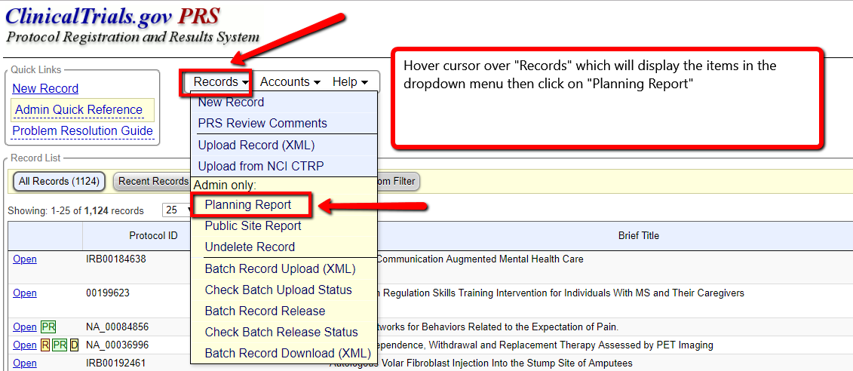
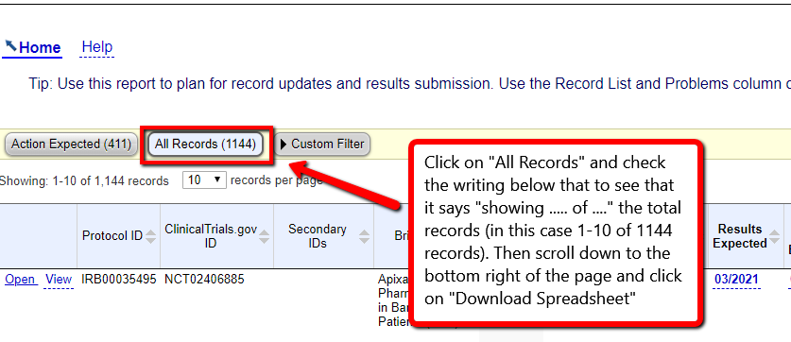
Open downloaded Planning report
Turn on filters as shown below
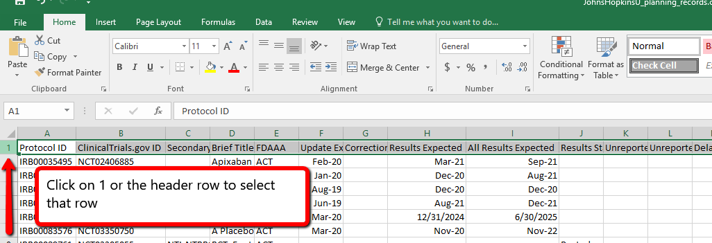
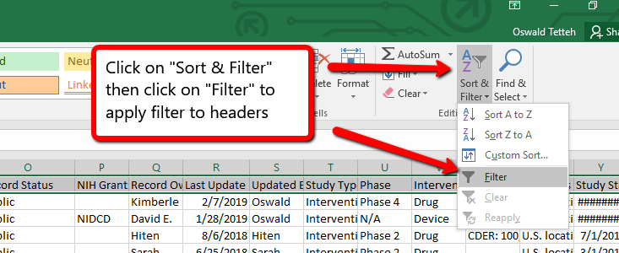
Locate Study Completion date and check the box for the current month and year
Locate Study Completion Date Type and uncheck “Actual”
Locate Initial Release and uncheck blanks if checked.
Locate overall status and uncheck “Withdrawn”.
Copy remaining IRB numbers onto worksheet (Column D) for the month in the Anticipated Verification dates spreadsheet for the year

