Using the “Admin Changes” Feature to Update the ClinicalTrials.gov registration number within eIRB
A “Change in Research” is no longer required to update the ClinicalTrials.gov National Clinical Trials (NCT) number within your Institutional Review Board (IRB) application. Simply utilize the “Admin Changes” function, which can be found on the left hand margin of your study “Application Workspace.” Promptly and accurately updating eIRB is required whether the record was registered by the study team (through a Johns Hopkins account) or by the Sponsor.
- Select “Admin Changes”
- Update the required information including the registration number.
- Do not include “NCT” in front of the registration number, there is now validation that only allows for 8, numeric characters
- Scroll to the bottom right and click “OK”

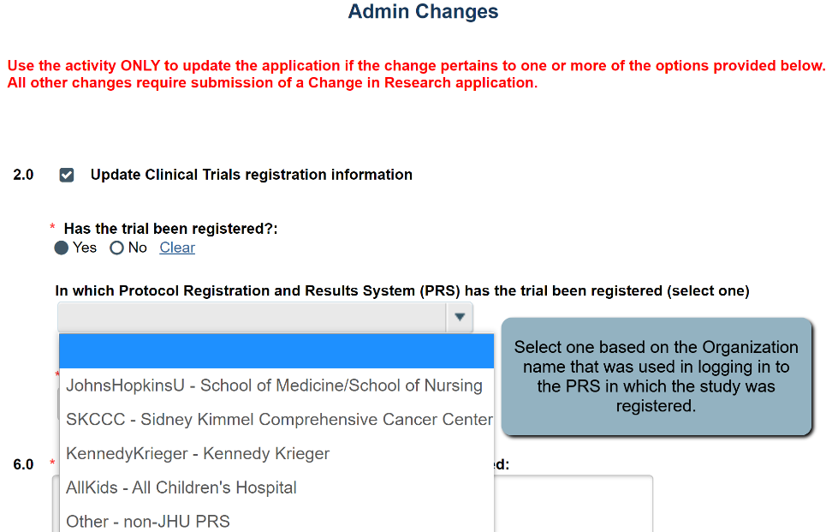
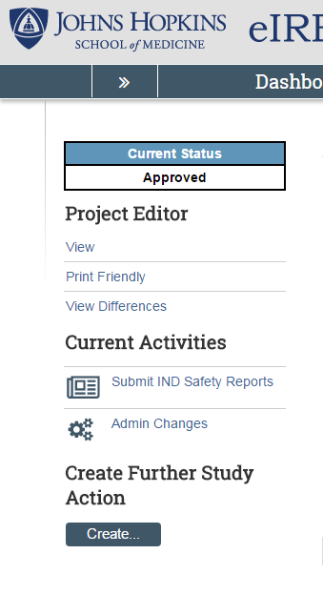

Further information can also be found on our ICTR – ClinicalTrials.gov Program Website
If you have any questions or feel this communication is in error please do not hesitate to contact the ClinicalTrials.gov Program (registerclinicaltrials@jhmi.edu) or the IRB.

