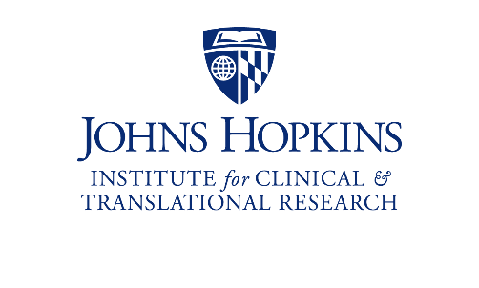
Capital Region Research (CAPRES)
Suburban Hospital, Sibley Memorial Hospital, Howard County General Hospital
Inpatient COVID Research

1 | Study Team  - A site PI must be identified and listed in the IRB application ( Section 10, Item 1)  - If CAPRES research staff are needed to facilitate the study, is there a budget for coordinator support?
2 | Lab Samples  - There are no BSL2 research labs onsite to process COVID samples  - PK samples cannot be collected  - All other samples must be sent via hospital lab courier to the JH Microlab for pickup by JH study team  - Lab and shipping supplies will need to be provided to the site
3 | Study Drug  - Prepare Investigational Drug Data Sheet for each product (Section 21, Item 10, sub-Item 13)
4 | IRB/Contracting  - The community hospital will need to be listed on the eIRB application (Section 10) and the study reviewed/approved by the local Research Review Committee prior to enrollment  - If industry sponsored, sites can be added to the same contract and budget if approved by the sponsor
5 | Department of Nursing Review  - Site Chief Nursing Officers will need to sign off on the Department of Nursing Review document

CAPRES Contacts:

Jackie Lobien  Director  301-896-3122  JLobien1@jhmi.edu | Mark Sulkowski, MD  Associate Dean  msulkowski@jhmi.edu

Website: ictr.johnhopkins.edu/capital-region-research-capres

